**VPC Endpoints**

**VPC diagram:**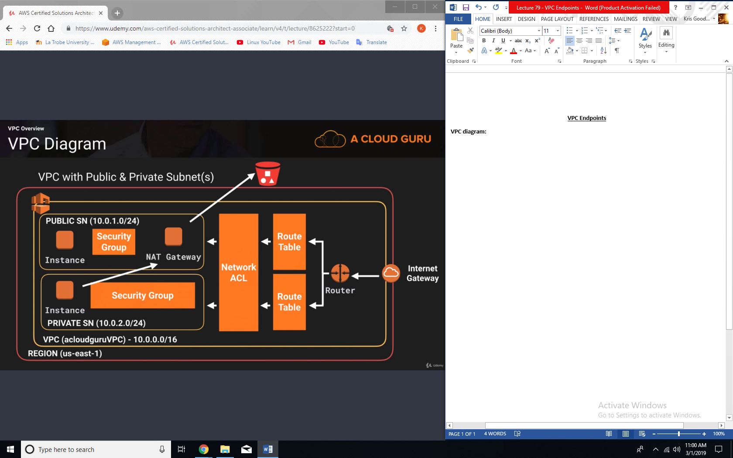

**Endpoints**

* Endpoints come in two different varieties:
  + Interface Endpoint: an elastic network interface that is going to be attached to your EC2 instances and it is going to serve as a point of entry to your traffic.
  + Gateways: very similar to NAT gateways, is not on a single interface or ENI, it is actually highly available and is available to all the different services.
* When you use an endpoint, the source IP addresses from your instances in your affected subnets for accessing the AWS service in the same region will be private IP addresses, not public IP addresses. Existing connections from your affected subnets to the AWS service that use public IP addresses may be dropped. Ensure that you don’t have critical tasks running when you create or modify an endpoint.